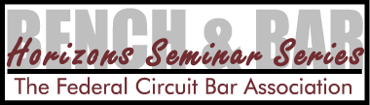
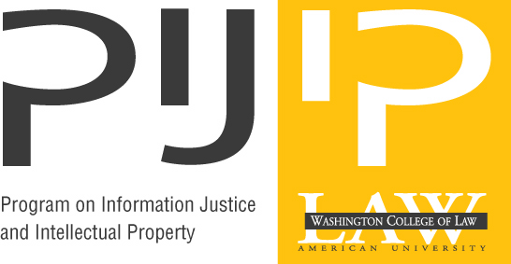

Patentable Subject Matter After the Bilski Oral Argument

A Telecast by the Program on Information Justice and Intellectual Property, Washington College of Law, American University
and
The Federal Circuit Bar Association

November 19, 2009

Washington College of Law
4801 Massachusetts Ave, NW – Room 603
Washington, DC

4:30- 6:30 p.m. EST

In Bilski v. Kappos, the U.S. Supreme Court will address limitations on patentable subject matter in the context of a business method invention, analyzing a body of case law in such a way that some say could wrongly call into question the validity of many other patents and types of claims, while others argue it is not restrictive enough. The oral argument – and the subsequent decision – will be studied by a broad range of members of the patent community who are seeking to determine its effects on innovation, prosecution, licensing, and litigation. PIJIP and the FCBA will host a panel of experts to discuss the case shortly after the Court hears the oral argument.

The panelists for this program include: Raymond T. Chen, Solicitor, U.S. Patent and Trademark Office, Counsel for Respondent, J. Michael Jakes, Finnegan Henderson, Counsel of Record for Petitioners, Nancy Linck, Rothwell, Figg, Counsel for Amicus Curiae BIO, and Randolph Moss, WilmerHale, Counsel for Amici Curiae Bank of America et al. A period for questions will follow. Thomas C. Goldstein, Akin, Gump, Counsel for Amicus Curiae American Bar Association and Professor Joshua Sarnoff, Washington College of Law, American University, Counsel for Amici Eleven Law Professors and the AARP will moderate.

In addition to on-site attendance, the FCBA will also broadcast the program live via the web on November 19, 2009 as a part of its regular Horizons series.

Price for Webcast

To register for this Program, please follow these instructions:
1) Those wishing to participate via the Internet, please visit our website: https://fedcirbar.webex.com and use registration password “FCBAbilski09”. Please enter coupon code that applies (listed next to each category above) upon checkout to receive discounted price.

2) Those wishing to participate On-Site, with or without CLE credit, please visit www.wcl.american.edu/secle/registration. Information about the program is also available at http://www.wcl.american.edu/secle/founders/2009/events.cfm.

3) For special “group” pricing and university law schools interested in FREE internet participation, contact Elisabeth Reed, reed@fedcirbar.org.

FCBA will seek CLE credit from applicable states for those registrants from within the United States (except OH, PA, IN, SC, & PR).

